Experiment 9: Configure remote VPN with IPSec

Aim: To configure remote VPN with IPSec using packet tracer.

Learning Outcomes:
After completion of this experiment, student should be able to

1. To understand need for VPN and IPSec.
2. To understand working of VPN and IPSec.
3. To understand various CISCO commands to configure remote VPN with IPSec.

Theory:
Remote access VPNs allow users to connect to a central site through a secure connection over a TCP/IP network. The Internet Security Association and Key Management Protocol, also called IKE, is the negotiation protocol that lets the IPsec client on the remote PC and the ASA agree on how to build an IPsec Security Association.

Each ISAKMP negotiation is divided into two sections called Phase1 and Phase2.
Phase 1 creates the first tunnel to protect later ISAKMP negotiation messages.
Phase 2 creates the tunnel that protects data travelling across the secure connection.

To set the terms of the ISAKMP negotiations, you create an ISAKMP policy. It includes the following:
• An authentication method, to ensure the identity of the peers.
• An encryption method, to protect the data and ensure privacy.
• A Hashed Message Authentication Codes (HMAC) method to ensure the identity of the sender and to ensure that the message has not been modified in transit.
• A Diffie-Hellman group to set the size of the encryption key.
• A time limit for how long the ASA uses an encryption key before replacing it.

A transform set combines an encryption method and an authentication method. During the IPsec security association negotiation with ISAKMP, the peers agree to use a particular transform set to protect a particular data flow. The transform set must be the same for both peers. A transform set protects the data flows for the ACL specified in the associated crypto map entry. You can create transform sets in the ASA configuration, and then specify a maximum of 11 of them in a crypto map

Procedure:
- Configure the following network.
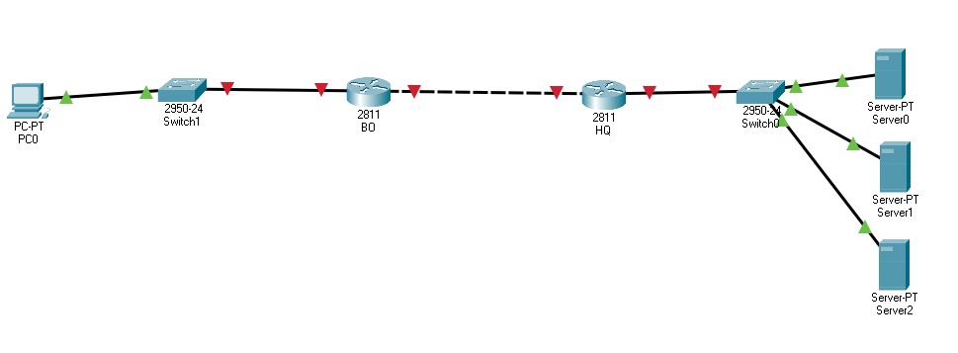
- Use following table for IP allocation.

Device | IP Address | Subnet Mask | Default Gateway
Server0 | Fa0- 172.16.1.10 | 255.255.255.0 | 172.16.1.1
Server1 | Fa0- 172.16.1.11 | 255.255.255.0 | 172.16.1.1
Server2 | Fa0- 172.16.1.12 | 255.255.255.0 | 172.16.1.1
2811- HQ | Fa0/1-172.16.1.1 | 255.255.255.0 | 172.16.1.1
2811- HQ | Fa0/0 – 10.1.1.1 | 255.255.255.0
2811- BO | Fa0/1 – 10.1.1.2 | 255.255.255.0
2811- BO | Fa0/0 – 172.16.2.1 | 255.255.255.0
PC-0 | Fa0-172.16.2.2 | 255.255.255.0 | 172.16.2.1

- Configure following on HQ Router
Router>enable
Router#
Router#configure terminal
Router(config)#ip route 0.0.0.0 0.0.0.0 10.1.1.2
- Configure following on BO Router
Router>enable
Router#
Router#configure terminal
Router(config)#ip route 0.0.0.0 0.0.0.0 10.1.1.1
- Ping 172.16.1.10 from PC-0. It should be successful.
- Configure following commands on the HQ router
Router(config)#aaa new-model
Router(config)#aaa authentication login prs1 local
Router(config)#aaa authorization network prs2 local
Router(config)#username admin password admin
Router(config)#crypto isakmp policy 10
Router(config-isakmp)#encryption 3des
Router(config-isakmp)#hash md5
Router(config-isakmp)#authentication pre-share
Router(config-isakmp)#group 2
Router(config-isakmp)#exit
Router(config)#ip local pool VPNPOOL 192.168.1.1 192.168.1.50
Router(config)#crypto isakmp client configuration group cisco
Router(config-isakmp-group)#key cisco123
Router(config-isakmp-group)#pool VPNPOOL
Router(config-isakmp-group)#exit
Router(config)#crypto ipsec transform-set set1 esp-3des esp-md5-hmac
Router(config)#crypto dynamic-map map1 10
Router(config-crypto-map)#set transform-set set1
Router(config-crypto-map)#reverse-route
Router(config-crypto-map)#exit
Router(config)#crypto map map1 client configuration address respond
Router(config)#crypto map map1 client authentication list prs1
Router(config)#crypto map map1 isakmp authorization list prs2
Router(config)#crypto map map1 10 ipsec-isakmp dynamic map1
Router(config)#int fa0/0
Router(config-if)#crypto map map1
Router(config-if)#exit
- Test and Verify VPN

Review Questions:
1. Explain the various modes of operation of VPN.
2. Explain working of IPSec.
3. What is security association?
4. Explain static and dynamic crypto map.

